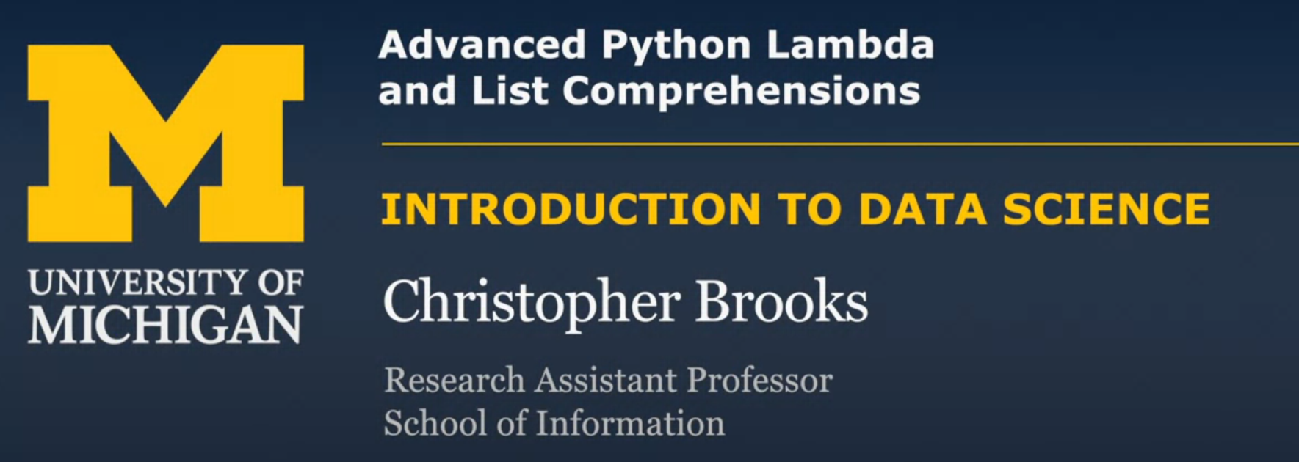

Lambda are really much more limited than full function definitions.

Lambda is very useful for simple little data cleaning tasks

